Electrical Signals 2

Propagation of Action Potential down an Unmyelinated Axon
This shows propagation of an AP from one adjacent area of an axon to the next over a short period of time. For each of the four areas in each time period:
● Indicate its state: D (Depolarization), R (Repolarization), RMP (Rest)
● Indicate which ion is represented by the arrows (Na⁺, K⁺).
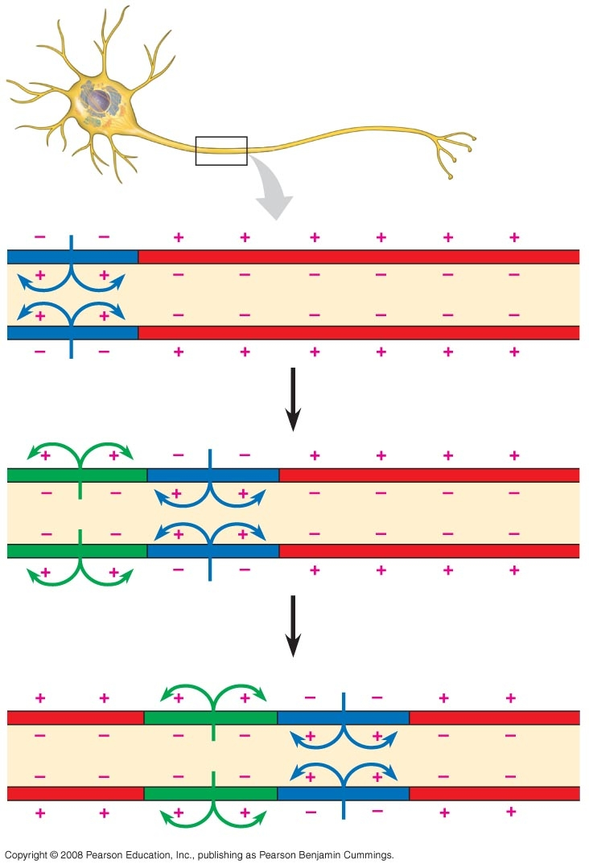
Saltatory Conduction
This shows propagation of an AP from one node of Ranvier to the next along a myelinated axon. Explain what is happening.

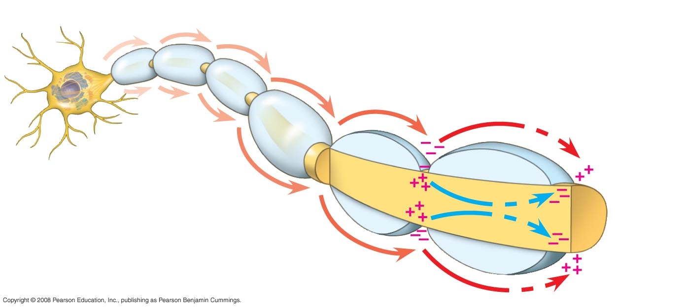

Explanation:
Saltatory Conduction
Diagrams A, B and C represent three adjacent areas of the same myelinated axon at successive points in time.

RMP = Resting Membrane Potential
D = Depolarization
R = Repolarization

On Diagram C, label the location of depolarization (D), repolarization (R) and resting membrane potential (RMP).

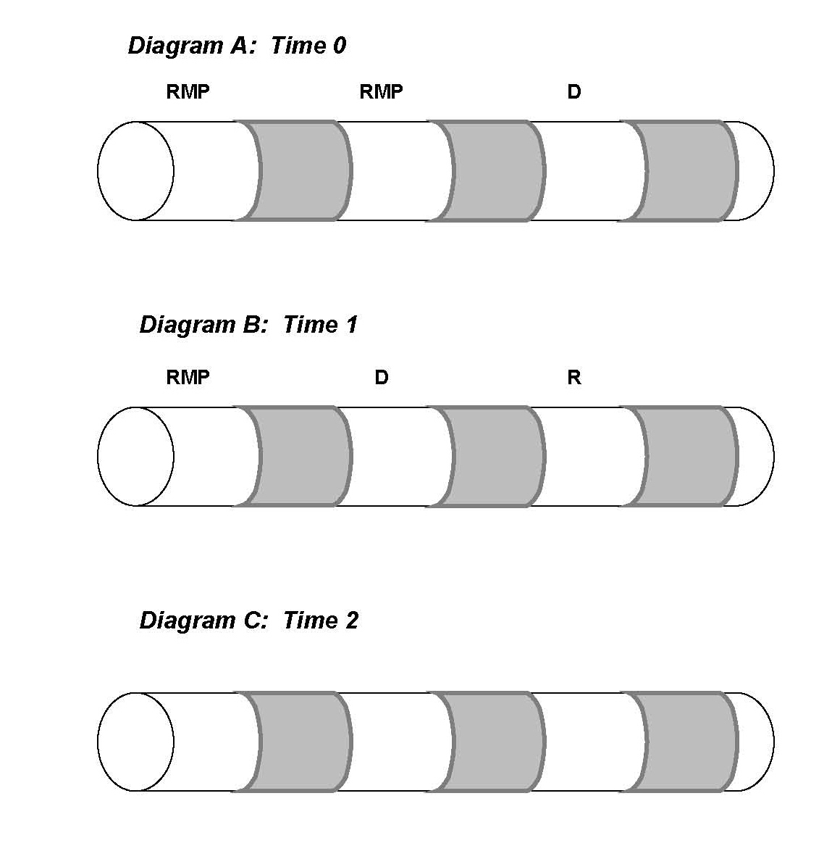

Chemical Synapse
Identify what is happening at each numbered step in the diagram.

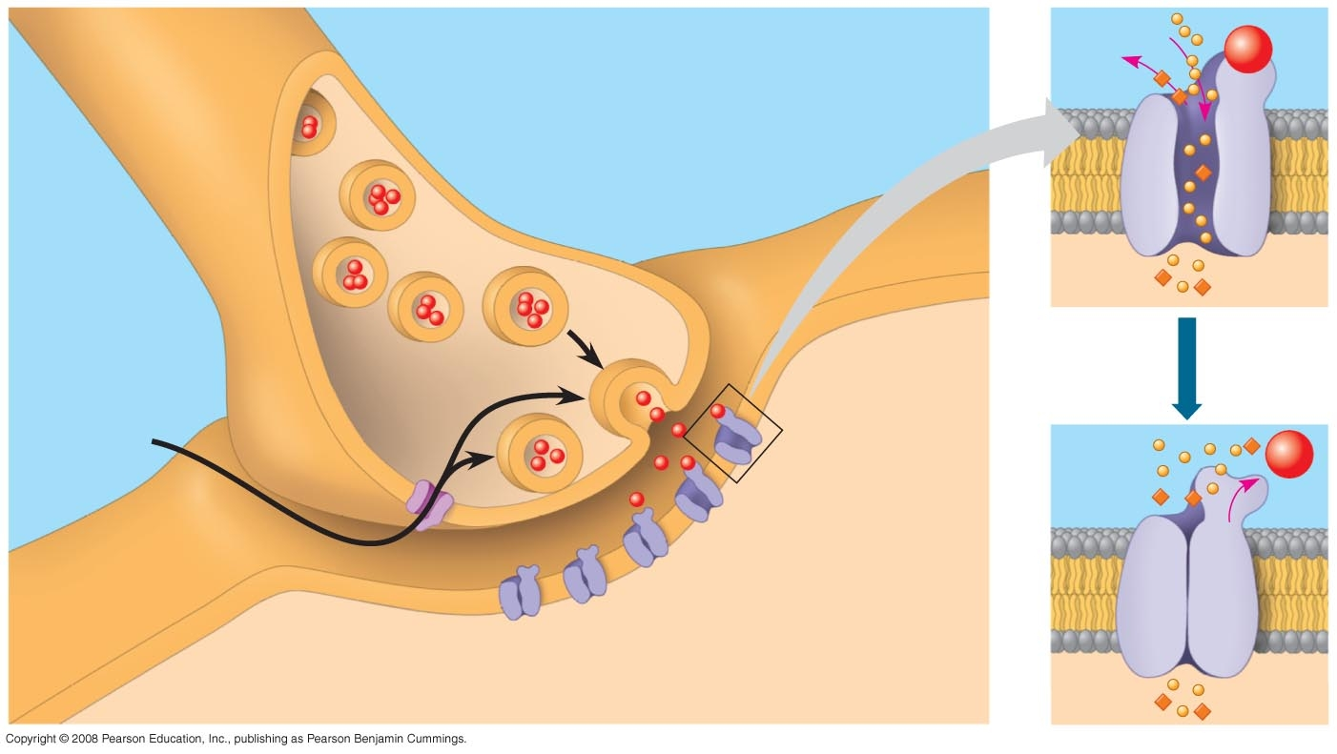
2
1
3
4
5
6
7

1. ______________________________________________________

2. ______________________________________________________

3. ______________________________________________________

4. ______________________________________________________

5. ______________________________________________________

6. ______________________________________________________

7. ______________________________________________________

